# **INSURANCE SYSTEM**

1. **INTRODUCTION**

Insurance maintenance system will help both customers and their agents to know about the current policies and enabling customers to select policies as per their choice. It deals with collection of Customer information, Policies available, Agents details, Number of policies sold by the customer, Terms and conditions applied to be agent and Feedback form. The main modules available are Customer and Agent. The Subparts available in customer module can be, Existing Customer information, Policies details and New Customer registration. The Subparts available in Agent module can be Existing Agent Details, New Agent registration and Terms and conditions applied.

1. **CONCEPTS USED**

* Functions
* Arrays
* Structure

1. **MODULAR DESIGN**

|  |  |  |
| --- | --- | --- |
| S.NO | MODULES | DESCRIPTIONS |
| 1 | cusmenu() | Gets information on customer details |
| 2 | newpol() | Gives information on the policy |
| 3 | oldagent() | Gets information on old agentr details |
| 4 | feed() | Gets feedback from customer |
| 5 | newagn() | Gets the new agent details |

1. **SOURCE CODE**

#include<stdio.h>

#include<strings.h>

#include<stdlib.h>

void cusmenu();

void newpol();

void oldagent();

void feed();

void newagn();

struct customer

{

char customerName[20];

int customerId;

char policy[20];

char newCustomer[20];

}c;

struct agent

{

char exsistingAgent[20];

char newAgent[20];

char termsConditions[20];

}a;

void cusmenu()

{

int choice;

printf("\n**************Customer Details*********\n");

scanf("%s",c.customerName);

scanf("%d",&c.customerId);

scanf("%s",c.policy);

printf("\nEnter 1 if you want to add new customer name\n ");

scanf("%d",&choice);

if(choice==1)

{

scanf("%s",c.newCustomer);

printf("\nCustomerName: %s \n",c.customerName);

printf("\nCustomerId: %d \n",c.customerId);

printf("\nPolicy: %s\n",c.policy);

printf("\nnewCustomer: %s\n",c.newCustomer);

}

else

{

printf("\nCustomerName: %s \n",c.customerName);

printf("\nCustomerId: %d \n",c.customerId);

printf("\nPolicy: %s\n",c.policy);

}

void newpol()

{

printf("\nnew policy details");

printf("\n1.health insurance");

printf("\n2.LIC policy");

printf("\n3.Bajaj Allaiance");

}

void feed()

{

char name[20],ans[20];

printf("\n---------------------FEED BACK FORM-------------------\n");

printf("Name: ");

scanf("%s",name);

printf("\nIS our policy satisfactory ??: ");

scanf("%s",ans);

}

}

void newagn()

{

int choice;

printf("\n********Agent Details*********\n");

scanf("%s",a.exsistingAgent);

scanf("%s",a.termsConditions);

printf("\nEnter 1 if you want to add new customer name\n ");

scanf("%d",&choice);

if(choice==1){

scanf("%s",a.newAgent);

printf("\nAgentName: %s \n",a.exsistingAgent);

printf("\nterms and conditions: %s\n",a.termsConditions);

printf("\nnewAgent: %s\n",a.newAgent);

}

else{

printf("\nAgentName: %s \n",a.exsistingAgent);

printf("\nterms and conditions: %s\n",a.termsConditions);

}

void oldcus()

{

int agentid;

Scanf(“%s%d”,&a.exsistingAgent,&agentid);

}

void main()

{

int choice,i=1;

while(i!=0)

{

printf("\n1.new Customer\n2.oldagent\n3.policy name\n4.feedback\n5.newagent\n");

printf("Enter the choice: \n");

scanf("%d",&choice);

switch(choice)

{

case 1:cusmenu();

break;

case 2:oldagent();

break;

case 3:newpol();

break;

case 4:feed();

break;

case 5:newagn();

break;

default:exit(0);

}

}

}

1. **OUTPUT**

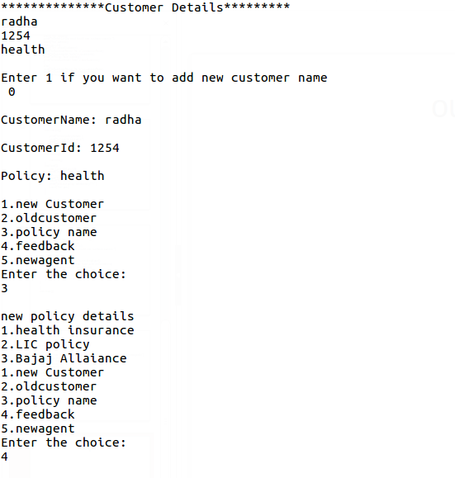

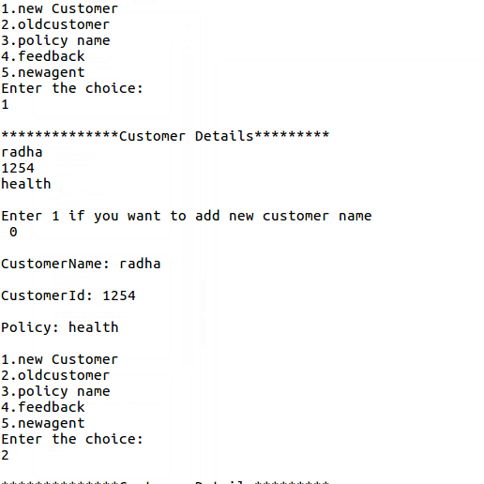 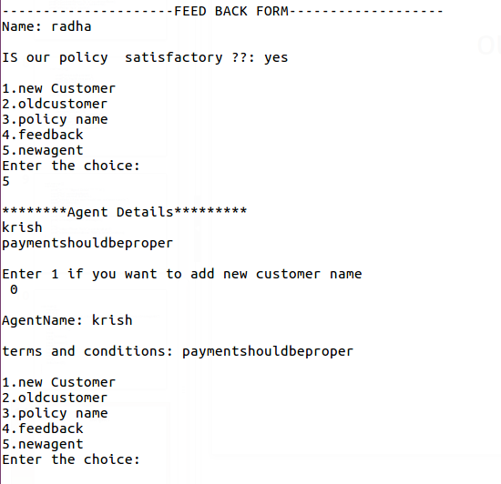

1. **CONCLUSION**

* Thus, The insurance management system has been implemented and the details of the customer,agent and policies have been displayed.